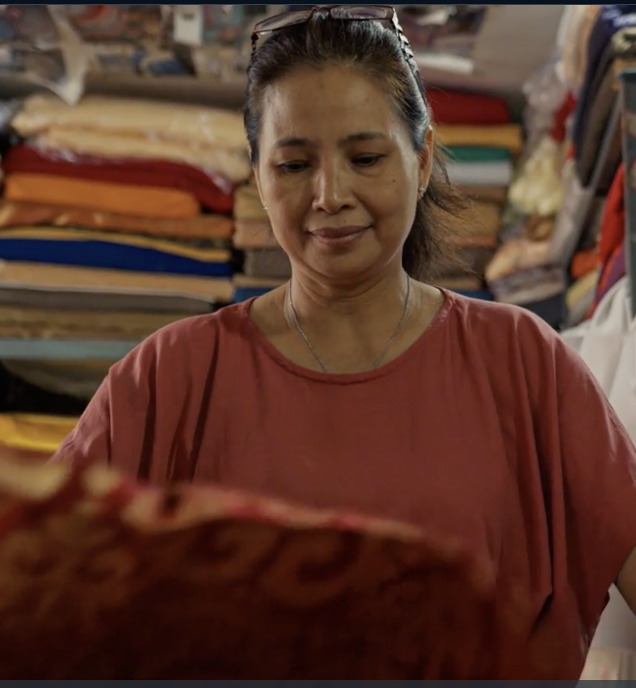
UNDP-Generali Insurance Innovation Challenge Fund:
SME Resilience in Malaysia

CALL FOR PROPOSALS

Table of Contents
Table of Contents 2
GENERAL INFORMATION 2
BACKGROUND 4
1.1 Development Challenge 4
1.2 The Insurance and Risk Finance Facility 4
1.3 Generali 5
THE UNDP-GENERALI INSURANCE INNOVATION CHALLENGE FUND (IICF) 5
1.4 Objective 5
1.5 Attributes 5
ELIGIBILITY 6
AWARD AMOUNT AND BUDGET 6
DURATION OF THE PROJECT 7
SUBMITTING APPLICATION 7
1.6 General rules for applications: 8
CRITERIA FOR SELECTING THE WINNER 8
ANNEXES 8

GENERAL INFORMATION

Type: | External Call for Proposals
Title of the Call: | UNDP_Generali: Insurance Innovation Challenge Fund (IICF)
Agency: | United Nations Development Programme (UNDP)
Managing Unit: | Insurance and Risk Finance Facility (IRFF)
Type of Contract: | Agreement between UNDP and the Winning Entities under the “UNDP Insurance and Risk Finance Facility: Call for the Proposals to the Insurance Innovation Challenge Fund”
Locality: | Malaysia
Expected date of contract start: | 1 March 2024
Expected length of contract: | up to 2 years
Estimated prize: | up to US$40,000 USD per successful applicant

BACKGROUND

Development Challenge
Micro-small-and medium-sized enterprises (MSMEs) are the backbone of many economies in the ASEAN region, accounting for 85% of the labor force. In Malaysia, MSMEs account for 97.2% of all enterprises, generated 38.2% of GDP and employed 7.3 million people in 2020. However, several risks threaten the survival of MSMEs in Malaysia and the ASEAN region as a whole, these include, but are not limited to, the lingering impact of COVID-19, difficulties in accessing finance and the growing threat of disasters. Southeast Asia is also one of the most hazard-prone regions, with annual economic losses due to disaster totaling more than $86 billion, mainly caused by recurring droughts, floods, tropical cyclones, earthquakes and tsunamis. In Malaysia, for example, small businesses are disproportionally impacted by risk, yet approximately 90% have no insurance coverage.
The insurance industry has a role to play in reducing this vulnerability by increasing the financial resilience of small businesses in Malaysia. Insurance can protect vulnerable households and enterprises from the adverse impact of shocks and crises, it also stimulates and incentivizes growth by stripping away uncertainty and risk. In addition, the Malaysian government has demonstrated a strong commitment to bolstering the resilience of MSMEs in the country by working with partners to create an enabling environment for MSMEs.
Insurance and risk transfer solutions not only protect vulnerable people and countries from the adverse impact of shocks, they can stimulate and incentivize growth by stripping away uncertainty and risk from society. Insurance and risk financing play a key role in tackling many of the interconnected challenges that countries, communities, enterprises and households face. They build financial resilience and reduce vulnerabilities to climate, socio-economic, health, and disaster risks and shocks, providing a critical safety net for millions by protecting assets, lives, and livelihoods. Use of insurance and risk financing to protect lives, livelihoods and assets is far from being fully realized as such the Insurance and Risk Finance Facility (IRFF) is launching an Insurance Innovation Challenge Fund focused on SME resilience in Malaysia to develop more solutions to reach underserved markets and scale insurance access.

The Insurance and Risk Finance Facility
The IRFF is a flagship initiative of UNDP’s Sustainable Finance Hub and is part of the wider UNDP Global Policy Network. It is the heart of UNDP’s insurance and risk finance support to UNDP country offices, programme countries and partners, providing policy and guidance, tools and methodologies, and networks and partnerships. It acts as a catalyst for the development and delivery of new insurance products, tools and services, while also investing in the long-term transformation of insurance markets, targeted at boosting country and community resilience to socioeconomic, health, climate shocks and other crises. The IRFF supports the development of innovative insurance products and services that are aimed towards vulnerable people and communities, while also investing in the long-term transformation of insurance markets. The Facility will deliver innovative protection solutions in 50 developing countries by 2025. Currently, the facility is operational in 30 countries working closely with industry partners to deliver policy advice, guidance, tools, methodologies and networks that boost country and community resilience towards socio-economic, health, climate and other shocks.
The aim of the IRFF is to work with partners to construct robust financial resilience of families and countries, in the face of rising climate risk, through inclusive insurance, risk financing mechanisms, governance and development, advocacy, research and evidence. UNDP’s IRFF implements this work at global and country level to scale insurance and risk finance solutions in the countries that need it the most by tackling supply and demand challenges and working side-by-side with the insurance industry to seize opportunities of providing protection and building long-term resilience.

Generali
Generali is one of the largest global insurance and asset management providers. Established in 1831, it is present in over 50 countries in the world, with a total premium income of € 81.5 billion in 2022. With 82,000 employees serving 68 million customers, the Group has a leading position in Europe and a growing presence in Asia and Latin America. At the heart of Generali’s strategy is its Lifetime Partner commitment to customers, achieved through innovative and personalized solutions, best-in-class customer experience and its digitalized global distribution capabilities. The Group has fully embedded sustainability into all strategic choices, with the aim to create value for all stakeholders while building a fairer and more resilient society.

THE UNDP-GENERALI INSURANCE INNOVATION CHALLENGE FUND (IICF)

Objective
In partnership with Generali, IRFF has developed the UNDP-Generali Insurance Innovation Challenge Fund (IICF) to facilitate and incentivize the development two solutions on small and medium-sized enterprise (SME) resilience in Asia. The proposed solutions must be scaling up existing solutions and tailoring them to currently underserved client segments while partnering with diverse distribution channels and integrating new technology solutions.

Attributes
Through the IICF, UNDP and Generali will seek out two or more or more innovative solutions that embody the following attributes:
The main attribute:
- Build SME resilience – To climate and other risks, allowing them to grow and invest, and be more productive. Products can cover, for example, stock and machinery, business continuity, staff, specific or multiple risks.
Other features of the product we seek include:
- Innovative – Introduction of innovative business models, technologies, ideas, or products that specifically focus on SME resilience in Malaysia;
- Sustainability – The project should demonstrate self-sustainability by the end of the agreed support period, this requires achieving sufficient scale and increasing efficiency and impact;
- Distribution strategy – Not simply selling insurance in isolation, complimenting other services demanded by SMEs;
- Sustainable Development Goals (SDGs) – Should show a demonstrable impact on the SDGs
- Scale Potential – The proposed project must have a potential for financial, social and environmental sustainability and scale-up;
- Gender – Innovations should also include a focus on ensuring gender equity. Applicants must ensure that gender perspectives and attention to the goal of gender equality are central to the proposed innovation.

ELIGIBILITY
The eligible applicants are insurance solution providers such as insurers, intermediaries and aggregators, insurtechs, distribution channels, and other related private sector actors. Entities wishing to apply to the challenge fund need to focus on solutions which address a development need through innovative thinking and assure viability in local conditions and to promote sustainability and scalability of the solution. Eligible applicants must already have an established insurance product or solution that they would modify or adapt to reach SMES (either in new geographies, or to leverage new distribution channels or technologies to scale access and experience).
Entities wishing to apply to the challenge fund need to meet the following eligibility criteria:
- Registered entity. The applicant must be a registered entity;
- Licenses. The applicant must have all the necessary licenses and permissions to sell and distribute insurance products in the country of implementation.
N.B The applicant that does not fulfill the license criteria above, may partner with one or more entities to fill the gap.
- Expertise and Capacity to Implement the Project. All applicants must demonstrate their capacity to implement their proposed project and will need to demonstrate adequate material, human and other non-financial resources to implement the proposed project within the set timeframe;
- Product. The funding request is for a specific, innovative project that supports the risk resilience of SMEs in Malaysia. The applicant must propose an insurance product(s) that it will modify or adapt in an innovative way to reach SMEs including: i) a new distribution channel, product, or service; ii) a new region; iii) a new segment or sector;
- Go to Market. Entities should demonstrate the ability to launch the product within 6 months of the award.

AWARD AMOUNT AND BUDGET
- Successful applicants will be awarded up to US$40,000;
- Technical assistance to support the development of the idea;
- Possibility to access the UNDP global presence (+170 countries) and networks to help support the selected solutions;
- Promising solutions could later be considered for further engagement as part of UNDP’s Insurance and Risk Finance Facility or other UNDP initiatives.
Typical items that can be covered from the Challenge Fund may include, but are not limited to:
- Salaries of project staff;
- Technology, design, business, development and other consultancy services;
- Advisory inputs;
- Small equipment and supplies;
- Training and workshop expenses;
- Other costs, including travel connected to the implementation of the project.
The expenses shown above should be predicted to reflect the project goals and should be clearly justified in accordance with the project objectives. Only expenditures accrued during the project in accordance with the project plan in line with project objectives necessary for achieving project outcomes and completed by the end of the project are eligible for financing. All agreements with subcontractors or third parties must be submitted with the application and must contain provision that the applicant retains ownership of all new intellectual property and know-how that may be created during the implementation of the project.
Expenses that will not be considered for financing by IICF include but are not limited to:
- Capital expenditures;
- Interest or debt owed to any third party;
- Expenditures and provisions for possible future losses or debts;
- Items already financed through another similar scheme, program or institution, financial awards;
- Bank and currency exchange expenses, losses, fees and penalties.

DURATION OF THE PROJECT
The Project must be completed within 24 months from the signature of the Innovation Challenge Agreement. A project will be deemed completed when the deliverables as defined in the Innovation Challenge Agreement are completed. These deliverables will be tailored to each specific project but will follow the structure of the Standard Innovation Challenge Agreement (see Annex 2).

SUBMITTING APPLICATION
Applicants are required to submit their proposal documents via the UNDP IRFF email address, which is: irffchallenge@undp.org with the following subject line: Insurance Innovation Challenge Fund: Malaysia and visit the UNDP website for more information: https://irff.undp.org/challenge-fund/malaysia
Additionally, the following documents must be included:
- Summary of the company, including any experience in developing inclusive insurance products;
- Documentation showing company registration which includes permission to operate and sell insurance in the country and insurance license;
- Financial statements;
- CVs of Experts who will be working on the development of the solution;
- Budget (excel sheet), including how the company will be contributing to the implementation of the initiative such as through in-kind or financial resources;
- Any other relevant documents supporting the application.

General rules for applications:
- Each entity may submit two applications;
- Deadline for application is to be strictly respected. In the evaluation process, only complete applications will be accepted;
- All submitted documents must be in English language;
- UNDP shall examine the proposal to confirm that all terms and conditions under the UNDP General Terms and Conditions and Special Conditions have been accepted by the Proposer without any deviation or reservation.

CRITERIA FOR SELECTING THE WINNER
- After the deadline for the submission, all duly submitted applications are reviewed against the eligibility criteria and completeness. All rejected applicants will get a notice accompanied by a short explanation. For these applicants, the selection process is finished. They also do not have the right to appeal.
- All eligible and complete applications will be evaluated by a UNDP Evaluation Panel
- Eligible and complete applications will be evaluated according to the evaluation criteria as follows:
  - Proposed innovative solution which builds on an existing product or solution (introduction of a new idea that shows development approach and impact, project quality including intervention logic and feasibility, product or service to a target group) with consideration of risks (40%);
  - Experience of management and development team in developing inclusive insurance products (20%);
  - Potential for scale up, replication and long-term sustainability (financial, environmental, social) (10%)
  - Value for money and cost-effectiveness (30%);
- Only applications that score above 50% will be evaluated in full and considered for awarding the project.

ANNEXES
Annex 1 – Application Form
Annex 2 – Call for the Proposals and Guidelines to the UNDP-Generali Insurance Innovation Challenge Fund
Annex 3 – Proposed Budget Detail

The Association of Southeast Asian Nations (ASEAN)
ASEAN Coordinating Committee on Micro, Small and Medium Enterprises, 2022 OECD, 2022; UNCTAD, 2021; ADB Institute, 2023;

